New words:
The British Museum- Британский музей
The Natural History Museum- музей естествознания
The museum of childhood-музей детства
The National Gallery- Национальная картинная галерея
The National Portrait Gallery –Национальная Портретная галерея
The Whispering Gallery – Галерея «шепотов»
The Westminster Abbey Museum – Вестминстерское Аббатство
The Tower- Тауэр
The Greenwich Observatory –Гринвичская обсерватория
Madame Tussaud’s Museum- музей мадам Тюссо
The museum of Transport –музей транспорта

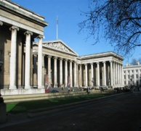
The British Museum is a museum of human history and culture in London. Its collections, which number more than seven million objects, are the largest in the world and originate from all continents, illustrating and documenting the story of human culture from its beginnings to the present. The museum first opened to the public on the 15th of January 1759. Its founder was Sir Hans Sloane. His portrait you can see on the picture.
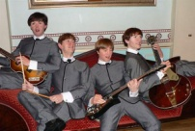
Madame Tussauds is a wax museum. It is an interesting tourist attraction in London displaying waxworks of historical and royal figures, film stars, sports stars. It is the best on a planet wax museum. There are more than 1000 figures of outstanding people of policy, the arts, outstanding commanders and great scientists. You have a good chance to have photos there.
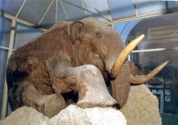
Natural History Museum is one of three largest museums located in the street Exhibition Road in Southern Kensington. The collection includes more than 70 million exhibits on botany, zoology (including mineralogy and paleontology). The museum is most known on its collection of skeletons of dinosaurs in the central hall, including the well-known skeleton of diplodock (length of 26 meters), and also is interesting by mechanical model of T-Rex. There is the 30-meter whale in a zoological. The museum has an interesting collection of meteorites.

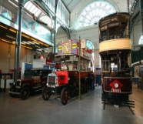
There is the museum of Transport in Covent Garden. There you can get into old trams and buses, and to sit down for a rudder of a modern train and the bus. It is very interesting to see this collection and to learn about history of English transport system. There are animation halls where you can become the bus driver.
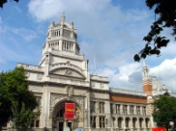
The Victoria and Albert Museum is the world's largest museum of decorative arts and design, housing a collection of over 4 million objects. Its collection contains the things from the cultures of Europe, North America, Asia and North Africa.
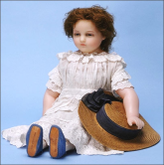
In a museum of the childhood of Victoria and Albert it is stored more than 8000 dolls, which tell us about the history, the fashion and customs of the people from ancient times till present, from the countries all over the world.
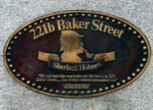
The address of the next museum is 221B Baker Street.
It is the London residence of the famous literary person Sherlock Holmes, created by author Sir Arthur Conan Doyle. There we can see the rooms and things which were described in the stories about this famous detective.

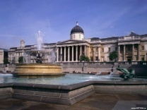

The National Gallery opened by the King George IV who wanted to buy a collection from 38 pictures. There are the pictures of Rubens, Rembrandt and other Flemish, Dutch and Italian artists of Renaissance. Near to the National gallery the National portrait gallery is located.
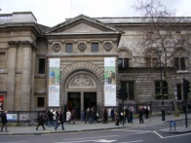
The National Portrait Gallery opened in 1856. It contains a lot of original portraits and photographs. The gallery is “about history, not about art”, which means that a picture gets into the gallery if it’s a portrait of a famous British person. The artist’s name and the quality of the picture are not important.
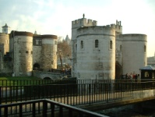

The Tower is a fortress in London which has played a prominent role in English history. The second name of the Tower is “Her Majesty's Royal Palace and Fortress”. Construction of a fortress has begun in 1078. It was a fortress, a palace, a royal prison and a royal zoo. Today the Tower of London is one of the country's most popular tourist attractions.

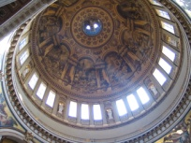
The Whispering Gallery is situated under the dome of St Paul’s cathedral. It is one of the most interesting places in London. It has the form of an ellipse. If one visitor will stand near a wall and whisper some words the other visitor will hear them standing in several meters at the same wall.
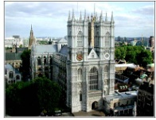
The Westminster Abbey Museum is located in the 11th century. This is one of the oldest areas of the Abbey, dating back to the foundation of the Norman church in 1065. It is the traditional place of coronation. This place has been used as a museum since 1908.
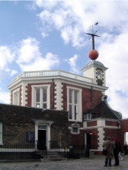
The Greenwich Observatory is the «beginning of the Earth». The prime meridian divides east from west. If you stand over the line you can have one foot in each hemisphere.

